CSA1013 SOFTWARE ENGINEERING
NAME: P ABHISHEK
REG NO: 192324111

Intelligent Retail Customer Behavior Analytics and Recommendation Platform

Case Study Analysis

Abstract
The retail industry generates massive volumes of customer transaction and browsing data every day. However, many retailers struggle to transform this data into actionable business insights. Traditional recommendation systems often provide generic suggestions, resulting in poor customer engagement and lower sales. This case study proposes an Intelligent Retail Customer Behavior Analytics and Recommendation Platform that integrates Artificial Intelligence (AI), Machine Learning (ML), Big Data Analytics, Cloud Computing, and Business Intelligence to analyze customer purchasing behavior, predict future buying trends, generate personalized product recommendations, optimize inventory, and support targeted marketing campaigns. The proposed platform enables retailers to improve customer satisfaction, increase sales, and make data-driven business decisions.

1. Introduction
The rapid growth of e-commerce and digital retail has significantly increased customer expectations for personalized shopping experiences. Retailers collect customer information through purchases, browsing history, loyalty programs, mobile applications, and online interactions. Conventional retail systems primarily focus on recording transactions rather than understanding customer behavior. AI-powered analytics helps retailers predict demand, personalize recommendations, optimize inventory, and maximize profitability.

2. Problem Analysis
Current challenges include:
• Customer purchase data is stored but rarely analyzed effectively.
• Traditional recommendation systems provide generic suggestions.
• Customer preferences continuously change over time.
• Inventory planning is often inaccurate due to unpredictable demand.
• Marketing campaigns target broad audiences with low conversion rates.
• Customer retention remains difficult because of poor personalization.

3. Stakeholder Analysis
Customers – Receive personalized recommendations.
Retail Manager – Monitors sales performance.
Marketing Team – Runs targeted campaigns.
Inventory Manager – Plans stock based on demand.
Data Analyst – Analyzes customer behavior.
System Administrator – Maintains the platform.
Business Owner – Makes strategic decisions.

4. Existing System Analysis
Strengths:
• Easy transaction management.
• Simple inventory recording.
• Basic sales reporting.
Limitations:
• No personalized recommendations.
• Poor demand forecasting.
• Inefficient inventory planning.
• Generic marketing campaigns.
• Lack of real-time business intelligence.

5. Proposed Software Solution
The platform integrates AI, ML, Cloud Computing, Data Analytics, and Business Intelligence to analyze customer purchases, browsing behavior, demographics, and seasonal trends. It generates personalized recommendations, predicts future demand, supports targeted marketing, and optimizes inventory.
Major Functional Modules:
• User Management
• Customer Behavior Analytics
• Purchase Pattern Analysis
• Personalized Recommendation Engine
• Customer Segmentation
• Sales Prediction
• Inventory Management
• Marketing Campaign Management
• Business Intelligence Dashboard
• Reports and Analytics

6. Software Engineering Considerations
Modularity, Scalability, Maintainability, Reliability, Security, and Usability are implemented through independent modules, cloud infrastructure, secure authentication, encrypted storage, and user-friendly dashboards.

7. Development Methodology
The Agile Software Development methodology is adopted to support iterative development, continuous testing, user feedback, and regular improvements.
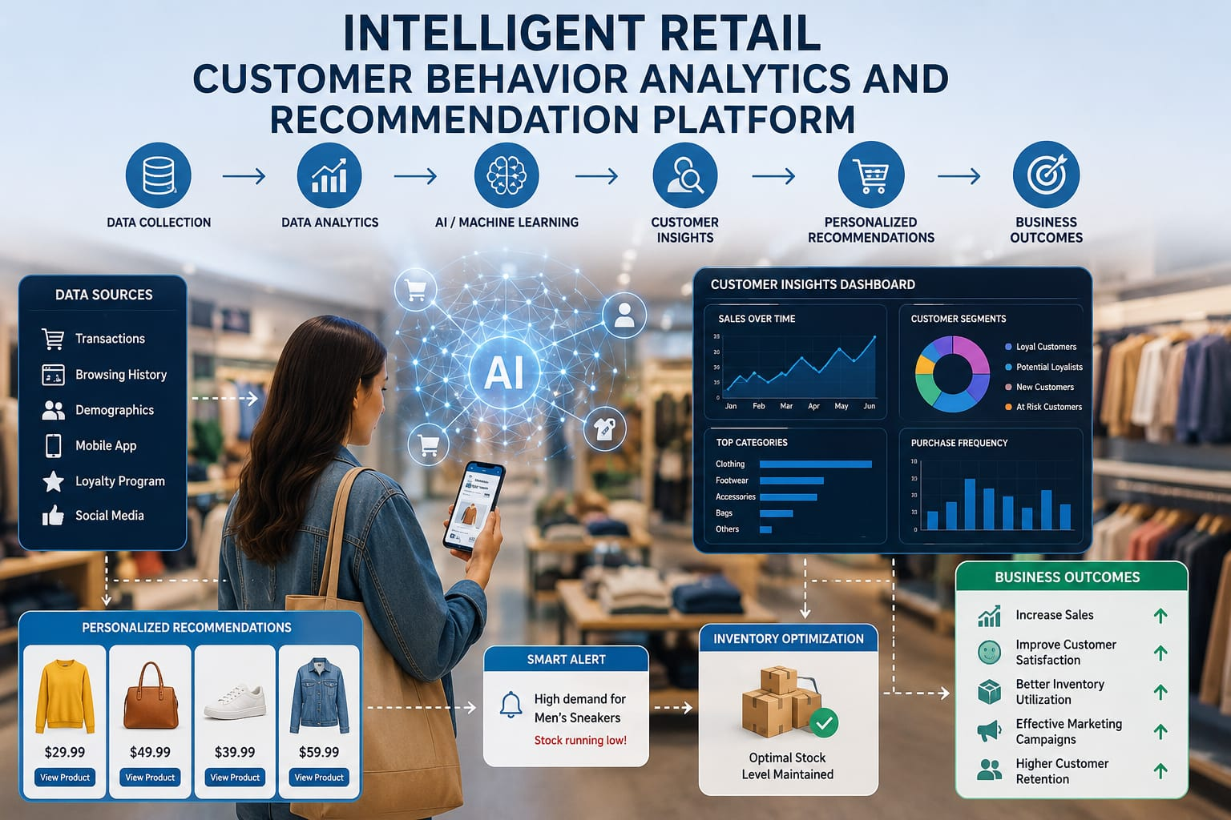

8. Expected Outcomes
• Higher customer satisfaction.
• Increased retail sales.
• Improved recommendation accuracy.
• Better inventory utilization.
• Effective marketing campaigns.
• Enhanced customer loyalty.
• Data-driven business decisions.
• Increased overall profitability.

9. Limitations and Future Scope
Limitations:
• High implementation cost.
• Large historical datasets required.
• Privacy and security concerns.
• Continuous AI model training.
Future Scope:
• Real-time recommendation engine.
• Voice-based shopping assistant.
• AR/VR shopping.
• Blockchain loyalty programs.
• Dynamic pricing.
• Generative AI assistant.

10. Conclusion
The proposed Intelligent Retail Customer Behavior Analytics and Recommendation Platform provides an AI-powered solution for customer analytics, recommendation generation, inventory optimization, and business intelligence. The system helps retailers improve customer engagement, profitability, and long-term business growth.

